Table of Contents

Major Project Logbook 2

Charts and Diagrams 11

IPO Diagram 11

Context Diagram 13

Data Flow Diagram 14

System Flowchart 16

Data Dictionary 17

Gantt Chart 18

Client Communication 19

Surveys 19

Communication with Executives and Students 24

Algorithms 25

Authenticate 25

Get Raw Student Data 25

Trouble Shooting 25

Check Calendar 25

Display Calendar 26

Main Loop 26

Admin Main Loop 26

Student Mainloop 26

Miscellaneous Documentation 27

Specifications & External Modules 27

File & Record Definitions 27

Test Data 28

Reflection 30

Website Screenshots 31

Prototype Screenshots 32

Major Project Logbook

20/10/2014

Today we got the notification of the first part of our assessment task. This first part, defining and understanding the problem, is probably the most finicky and seemingly most useless part of the major project assessment. But in terms of the Software Design and Development timeline it is almost the most important. Although in many Software design approaches, the defining stage is fairly unimportant – including RAD, agile and prototyping but in the approach I am using, a custom mixture of structured and agile, the defining stage is extremely important if not fundamental part of my project.

23/10/2014

This week has mostly been a week for considering considerations for the design phase of my software major project. The considerations I made include:

* The Design Approach
  + I have swapped a few times between Structured, Agile and a mixture of the two as well as the prototyping approach. I am still considering which to do and will have to look further into how they will affect the timeline of my project overall
* The language I would be using
  + I’m fairly sure my project will use Python, but to interface with the hardware of my project I may need to dabble in C++ and or lower level languages.

These two parts of my project are probably some of the most important of my whole project and will probably have to be considered and contemplated for the remainder of this part of the assessment

27/10/2014

This is the second week that we have had this first part of our assessment task. The defining stage of our assessment overall includes taking into account the perspectives of the User and the Developers from opposing perspectives. My idea, being a student management system aimed at my own school, is fairly easy to know the specifications of. Even taking this into account I still need to contact users – students, teachers, etc… to find out the exact specifications of what they want and how they want to be able to use it. I will start this communication at some point in the future but for now I will contemplate the specifications that I have defined myself as the user and developer

29/10/2014

Today I solely thought about how my hardware will work and and how the components will work together. The Hardware I will be using consists of:

* 7” Touch Screen
* Raspberry Pi (128Mb)
* RFID/NFC Card

The Touch screen interfaces with the Raspberry Pi through a graphics board and an HDMI cable. The Raspberry Pi interfaces with NFC/RFID card via IO ports

3/11/2014

Today was a fairly un-productive day for me in terms of my project. I have attempted to get the Gantt chart creator I have previously used working but apparently IT has decided my computer isn’t to run Java. This problem will take a fairly long while to fix if my experience has told me anything but I can’t be sure as of yet.

6/11/2014

Today I enquired with teachers as to what they thought of my project and what features they would want if this new system was to be implemented. This dialogue didn’t go very in depth but it did still give me insight into what people really liked and what they didn’t like so much.   
  
As well as this today I started on some of the harder documentation today Including System Flowcharts, Structure Charts and Data flow diagrams

10/11/2014

Today I have contemplated putting up a survey onto social media so as to start more dialogues on features and functionality that people want and would use. The survey would only have 5 or 6 questions but would ask if my project is really needed and what about it its needed the most.

Additionally to this I have started to contact people about 3d modeling a case to be 3d printed and used for my project. So far I have only talked to one person but they have expressed interest in helping me with this project.

13/11/2014

Today was an extremely productive one. I have started and finished work on the following elements of my project:

* Storyboard
* Data Dictionary
* System Flowchart

Although these parts are finished they made need some sort of revision at some point due to changing needs and the dynamic nature of the way I think about problems.

In addition to this, recently I have been given all the needed parts of hardware to get my project running, so today I drew up a plan of how I am to connect all of these elements in an efficient and practical manner. Unfortunately this also raised a few issues to my attention including my lack of knowledge in the field of soldering and my deficit of breadboards, wires and power supply’s.

17/11/2014

As the due date for this part of my assessment gets closer, I have started devoting more time and effort into this assessment. Trying to gather more knowledge and know-how in terms of the hardware and similarly gathering information on how to write some of the documentation. The documentation in particular that I need help with is the stuff we haven’t done in previous years and have been taught little to nothing about including:

* Quality Assurance
* Identifying the Problem
* User Feedback
* Test Data & Expected Output

Although ‘Identifying the Problem’ and ‘User Feedback’ are fairly self-explanatory which has made it exponentially easier to construct these myself. By fair the factor that makes it the hardest to learn about these elements of documentation is that we are going on with mostly irrelevant course work in class, which is fair enough, but indeed it does not help to complete a Quality Assurance criteria when we are learning about exponential, linear, hyperbolic, etc time.

20/11/2014

Finally I have created a working model of my project! And by working I mean the green light stays on for longer then 3 seconds and by project I mean the RFID/NFC module, although it won’t be properly working until I can solder the wires into the module and get the API/Library/Binaries to compile and work properly. Furthermore today I was able to get a start on some of my Quality Assurance criteria, after many periods of inconspicuously searching the internet for examples of Quality Assurance criteria I found a few useable recourses. Unfortunately for me these recourses got me nowhere in the eyes of our assessment, giving me only code tests I already knew of including but not limited to:

* Rubber duck checking (my personal favorite)
* Speed tests
* Peer Checking
* Code Criteria
  + Casing
  + Commenting (Intrinsic and explicit)
  + Sub routine length limiting

Additionally to the problem that these are only a small number of tests, they only apply to the code and as such give me no ability to test my system as a whole and other parts that are more user orientated.

24/11/2014

Today I finally decided to publish a survey, using Google forms, I constructed a 6 question survey that attempted to prove there is a need for my project and then find the specific features people liked best. Here are the specific questions:

**1. What is your role in Emanuel School?*Required**

* Student
* Teacher
* Admin Staff
* Other:

**2. What Time Do You Get To School Each Day?\***

**3. Do You Catch The School Bus?\*** 

* Yes
* No

**Do You Think There Is A Problem With Our Current Attendance System?*Required**

* Yes
* No

**If You Answered Yes To The Last Question, Please Expand On Said Problems.*Required**

**Do You Think We Need A New Attendance System?**

* Yes
* No

**What Would You Like To See In A New Attendance System?*Required**

**Do You Use Edumate To Check Your Calendar?*Required**

* Yes
* No

**Do You Like The Idea Of An Opal Card Style Attendance System*Required**

* Yes
* No

**Would You Use Edumate More If You Could Check Your Calendar Using Your Opal Style Card At A Computer Around The School?*Required**

* Yes
* No

As is quite plain to see this survey goes about, quite bluntly, answering the questions I want to know. Hopefully soon enough I will know of the answers to this survey. It’s interesting to note that, in my mind, the point of the survey is more to cement the need for the product I have developed from a student point of view rather than a teacher and/or administrative point of view.

27/11/2014

This evening, in a vein attempt to relax, I have started to force the raspberry Pi I am in possession of to work. In short all this means is for the touch screen to work in a calibrated fashion, sensing a finger and moving the mouse accordingly from a relatively precise starting point. Unfortunately computers don’t really like me and so this did not happen, but rather at first the touch screen didn’t work at all. After fiddling with wires and power supplies for a while I finally had some idea of what was happening, I needed a driver to get this touch screen to interface properly with the Pi. I though this might happen so I was prepared and installed an program on a kernel level that is built to help the raspberry pi specifically interface with the touch screen I had purchased. At this point I would again like to note that computers really don’t like me and so, as could only happen to me, the program did not see the interface. This forced me to search around on the internet for a few hours whilst the raspberry Pi sat there and though about what it had done wrong, so as usual it sat there in an idle state. I think it’s interesting to comment that quite a few things have gone wrong with this set up that the website assured me wouldn’t with it’s introductory video:

* The power supply was not there and neither was the needed polarity
* The drivers were not noted down anywhere – on the internet or intrinsically
* The way the screen was to be physically connected, although fairly menial, was not noted ANYWHERE and so I had to guess and check almost as much as I do in 3 unit maths
* Lastly the only way of knowing whether the touch screen is working or not is this tiny green LED on the smallest power board you have ever seen

All in all this touch screen has been one of the biggest pains in this project so far.

1/12/2014

On a very fitting date, today was like an early Christmas for me. After sending the link for my survey to many a person, when I checked the responses this afternoon it seemed I had accumulated quite a few responses (20 in fact). These responses ranged from silly and not at all useful characters instead sentences to extremely constructive feedback. Bellow is a sample of some of the better responses:

|  |  |  |  |  |  |  |  |  |  |  |  |  |
| --- | --- | --- | --- | --- | --- | --- | --- | --- | --- | --- | --- | --- |
| Student | 8:40:00 AM | Yes | Yes | Too many kids are being too lazy and are not signing in at the office. | Just like at Sydney Boys, each student should have to swipe a card as they walk through the gates which will monitor on the school system what time kids arrive and leave school.  Each student should get assigned a card. | Yes | | | Yes | | Yes | Yes |
| Student | 7:45:00 AM | No | No | It's hard to tell really, I think the computer system stuffs up attendance too frequently though. | Something easy to follow and more reliable that doesn't say someone isn't here when they are | No | Yes | Yes | | Yes |
| Student | 8:00:00 AM | No | Yes | Occasionally, even though on an excursion students are marked as absent | An online way for students to give their reasons for not attending school or being late | Yes | Yes | Yes | | Yes |

As you can see these responses were actually useful and do infact cement the need for the project I have created. Hopefully, as soon as Mr Drake sends my link to the teachers and Admin staff, I will get some more responses from a different, but still as important, demographic.

4/12/2014

Thankfully after looking around the vast expanse of the internet for a little while, I found a very nice German gentlemen who had developed a bootstrap/ XBMC application that interfaced with the touchscreen perfectly even though the program was originally built as an in car entertainment system. So after trimming the fat of his beautifully coded application I was able to get the touch screen display calibrated and working with Raspbians default IDE. This sets a very nice basis and creates a well needed proof of concept that will only be topped by the first working prototype of the much more finicky NFC/RFID module.

In addition to the hardware part of my project, which seems to have taken over my last few days, I have also finished off some of my design documentation including:

* Development Approach
* User Feedback
* Log Book (Up to Date)
* IPO Diagrams
* Context Diagram
* Data Dictionary

The only pressing pieces of documentation are:

* Gantt Chart
* Social and Ethical Issues
* Test Data and Expected Output
* Identifying the Problem in it’s fullness
* Quality Assurance

8/12/2014

Today has been a fairly productive day, although I haven’t exactly done a lot. I am finalizing my documentation as the project is due at the end of this week and as such I have added the finishing touches to the following documentation:

* Social and Ethical Issues
* Test Data and Expected Output
* Gantt Chart

In addition to all of these I have finished off my Project website, uploading a zip file of all my documentation to said website. After this I then went on to survey more of my user feedback to find that I had a few more entries, which have only affirmed the need for a new system.

13/12/2014 – 28/01/2015 Holidays

Over the holidays I accomplished very little in terms of actual documentation, but in terms of hardware and software I have made a lot of headway. Over the 1 and a half months of holidays we were allotted I was able to finish a hardware prototype of my project where all the parts were connected together. Technically this should’ve have enabled me to connect and retrieve data from these peripheral devices but as is always, some part of the computer held me back from doing so. In this case, I believe it is the operating system that is not allowing me to complete a fully functional prototype. Overall the holidays were an extremely productive time for my project’s hardware prototyping and to an extent the software side, but to no extent a productive time for my project documentation, as is rendered obvious by this short project log entry. This pretty much leaves me at a complete loss about this project. There are some work arounds to this but they’re completely uneconomical and completely contradict the purpose of this lightweight, easily implementable, affordable system.

30/01/2015

Today, with the starting of school and other such distractions, I was unable to really make much progress into my project, and as we don’t have the notification for our the next part of our project yet I can’t really accomplish anything apart from trying to get a working version of my prototype, which I will ask Mr Drake to help me with at a later date. To summaries this in dot point form:

* Build a working prototype
  + Ask Mr Drake for help with this
* Find the date and requirements of the next hand in assessment

3/02/2015

Although, Today, I’m still at the same point with the building the actual prototype, I have been able to specify what the actual problem is with the prototype I have. The specific problem I have found with my prototype is that it can’t access both the touch screen and the NFC/RFID chip at the same time, which is an obvious problem for the prototype and the end product. The only thing I can see that would cause a problem like this is not enough of the necessary drivers in the install of the Touch Screen. The method I’m using cross – compiles the kernel on a different machine, adding drivers for the touch screen. It is important to note that this is the point I think that this may be the step that negates the drivers that make a data transfer across the GPIO pins possible. The only reason I say this is that before the cross compilation I can access the data polled using a program from the standard library. Once the cross compilation is complete and I mount the new kernel on an SD card the Touch screen does tend to work after a bit of fiddling but the NFC/RFID chip definitely does not.

5/02/2015

This week I still haven’t been able to talk to Mr Drake because of our conflicting schedules but I have made a bit of progress into new ways in which I can compile a new kernel with drivers for touch screen support. The first being a graphical interface with underlying UNIX kernel which would allow me to confirm the drivers I want to be installed for a compilation and mounting by the Raspberry Pi itself.

10/02/2015

After thinking about my project for a bit longer, I feel I may not have explained the problem completely so I will try to do it again in proper English. The problem is that the prototype was unable to retrieve and send data to both the touch screen and the NFC/RFID chip on the same build. To explain this in better English, one build of the operating system for the Raspberry Pi was able to utilize the touch screen to its full extent of usage – including posting to the screen, retrieving mouse input and utilizing that input. Unfortunately on this same build it was unable to connect and retrieve information from the NFC/RFID chip whereas on a separate build version the raspberry pi OS was able to. After finding new ways of adding the needed drivers to the OS and installing and re-installing these drivers, I was still unable to find a configuration in which both the NFC/RFID chip would work as well as the USB TTF 7 inch Touchscreen.

12/02/2015

In the last few days I have attempted the new method of compiling a new kernel and unfortunately, as I have learnt in the last few days it takes a genuine millennia to compile. Like I’m talking about a whole day and night for it to compile on the raspberry pi, and then even longer to mount and check if it is even slightly functional. This makes it very hard to attempt more than one compilation per week making it extremely hard to go about a trial and error method in making the NFC/RFID chip co-exist with the Touch screen.

17/02/2015

Today was the second trial at compilation I have done and it yielded some results. I wasn’t able to get the two peripherals to work on the same build of the kernel but I did get an interesting error message from the NFC Chip:

error libnfc.driver.pn532_uart pn53x_check_communication

error lt-nfc-poll: ERROR: Unable to open NFC device.

What this does is it reaffirms my theory that it is in fact a GPIO driver that is missing and causing the OS to not be able to connect, communicate or retrieve data from the NFC/RFID Chip. What this means in the long run is that there will need to be many more trial runs of this, adding and re-adding different libraries and drivers to try and see which configuration works, if any at all.

19/02/2015

Approximately a week ago we were emailed a draft of our next hand in for our major project. As was expected it is a completely documentation based assessment. The requirements are as follows:

* Gantt Chart
* Logbook
* Client Communication
* IPO Charts
* DFDs
* Structure Charts
* System Flowcharts
* Data Dictionaries
* Prototype Screenshots
* Algorithms
* Specifications & External Modules
* File & Record Definitions
* Test Data
* Reflection
* Website Screenshots

A lot of these requirements have already been fulfilled from the former assessment task (Term 1) but these, apparently, must all be more detailed and there is also the obvious addition of a few more parts.

24/02/2015

Last week we got a draft assessment task notification and the week before that we also got our assessment marks from last term, and a little bit of a sneak peek into what we did wrong. I believe this will be an integral part of my next assessment so I’ll need this back properly before I even attempt to start my next assessment. So to create the illusion of me starting my project, I have decided to build my project website today. So far all I’ve been able to is create a slideshow of Major project puns in JavaScript, but it’s better than the link to a zip file that was my entire last project website.

26/02/2015

I only remembered to record this now, but I talked to Mr drake about what I should with the two most important peripherals of my project not working together and he suggested this. I should first get them to work, with python, separately and then, together we will work on a solution to the problem I have found. Fortunately for me I have already worked a way to access data from the NFC/RFID chip through python which is essentially just python running the standard polling program through a command interface and then retrieving the data through the same interface. Unfortunately as I’ve always strived to get the two peripherals working together, I’ve never had a build where the touch screen worked for long enough to test if I could create a working application in it. But in saying this, on my computer I have been able to create an application that can be used through mouse input and as the touch screen is essentially mouse input as far as the OS is concerned, it (Hopefully) should work in just the same way. Additionally today, having finalized my Gantt Chart, I’ve Started work on the following items:

* Project Website
* Prototype
* IPO Chart

As is to be expected throughout this project, I am in concurrent communication with the Users and Customer.

*3/03/2015*

Today I was able to start updating the rest of the integral pieces of documentation for this new design phase of my major project. These Items include:

* Data Flow Diagrams
* Structure Chart
* System Flowcharts
* Data Dictionaries
* Algorithms
* Specifications and External Modules
* File and Data Record Definitions
* and Test Data

With the exception of Specifications and External Modulesand File and Data Record Definitions I was able to get a good portion of all of these peices of documentation done quickly and efficiently, the only difference being for these two types of documentation I needed to some reasearch as to what they actualy are. In addition to this Today I have marked the start of me continued perservearance in getting the touch screen I am in possesion of to work with the Raspberry Pi I'm using and the NFC/RFID Chip I have as well. To say the least I hope my sanity stays in tact throughout this process

*5/03/2015*

The few days have been filled more with English practice essay's than software so I do not have much to report on in terms of my project. On the upside, in class today I made the quick decision to create the GUI for my project in Python's module 'Tkinter'. I have had some experience with Tkinter in the past and I beleive that its complete and uter lack of visual complexity is perfect for what want to do. In adition, the simple fact that Tkinter comes already installed on every Unix based operating system, with Python, means that in the future if I want to change OS's or Platforms as long as Python is installed this part of my project will be fine.

*10/03/2015*

Today, ignoring Math study, I was able to make a bit of headway in the bulk of my documentation. In saying that I am currently just trying to get a draft done so that Mr Drake can look through and tell me what's wrong and what isn't complex enough. So wihtout further adue here is the list of documentation I drafted today:

* Data Flow Diagram
* Structure Chart
* Data Dictionaries

These charts/diagrams were essentialy copied from my earlier project and were then edited to include a few more levels of complexty - in particular the DFD which gained a whole nother level of complexity now that I have some sort of idea hwo the data and logic structures of my project are going to work and interact.

*12/03/2015*

This week I have, again, been mainly studying for the two Math tests I have in the next week or so. This has hindered my ability to get anything of real use done (although I somehow got some of the more nity gritty charts/diagrams finsihed earlier in the week) so I decided to focus on building a somewhat functional prototype in the small amounts of downtime I do actualy have. This meant trawling through forums on solutions, explanations and more problems pertaining to why my configuration of hardware wasn't working and how I could get it to work. Eventually I was lead to a github repositroy containing the source code for the newest raspbian kernel and issue posted by a user which was the exact embodiment of my problem and the problems any solution I had found may cause. He explained how there was no out of the box drivers for most touch screens and specifically eGalax Touchscreens (The one I'm using) and the only way to get them to work is to recompile your own kernel with added suport, which is finicky and has the added problem of needing to be recompiled each time a patch is released - not something any person who values there sanity and time wants to do. Thankfully by this point one of the moderators had flagged the issue and by the time I got to it it looks like the driver support has been added into the latest source code for the kernel. So it seems there may be hope yet for my project!

*17/03/2015*

Having finished all of my Maths exams I know have magnitudes more time to spend on my project, which means today I finished a lot more documentation (Yay I hear you say whilst reading this, I only hear this because I am now clinically insane). The list of now completed documentation (Drafted) is as follows:

* System Flowcharts
* Algorithms
* Specifications and External Modules
* File and Data Record Definitions
* Test Data
* IPO Chart

*24/03/2015*

This week I was able to go through all of my documentation with Mr Drake and he has confirmed that with the exception of a few errors, my documentation is to an exemplary standard. This is a good thing because now I have time to go over my documentation and make sure it is all cogent and valid across the board. This also gives me time to get a head start on the next stage which, I think at this stage will involve me getting a new touchscreen or input device.

Charts and Diagrams

# IPO Diagram

|  |  |  |
| --- | --- | --- |
| Input | Process | Output |
| Student with a valid ID presses login and taps their card | Login (Student):   * System takes User ID, * Queries the local database for a match * If match is found output true Adds User to Edumate authentication stack. | A value is returned that represents whether the NFC card the Student has tapped holds an ID that is present in the Database |
| Admin with a valid ID presses login and taps their card | Login (Admin):   * System takes User ID, * Queries the local database for a match * If match is found output true Adds User to Edumate authentication stack. * System then checks if User ID is in admin.txt | A value is returned that represents whether the NFC card the Admin has tapped holds an ID that is present in the Database and in the Admin Users File |
| Student with an invalid ID presses login and taps their card | * System takes User ID * Queries the local Database for a match * If no User ID match is found when system will check for time since last database update, if it is outside a certain time frame the system will re-download and subsequently re-authenticate. * If authentication still fails a False Boolean is returned | A value is returned that represents whether the NFC card the Student has tapped holds an ID that is present in the Database |
| Student Clicks the Check Calendar Button | Check Calendar:   * System will take the stored User ID, * Query the Edumate calendar database with said User ID. * If a macth is found this data will then be returned * A function will then change this returned data into a 2 dimensional array that is then returned as a table in the GUI | The User Specific Calendar for the current day is returned in a GUI element. The actual data is returned to the display calendar function as a 2 dimensional array in the form [[Teacher, Subject, Classroom]] and it is assumed that the formatting function has put each term of the array in order of its time slot |
| Student with no Edumate Calendar clicks the check calendar Button | * System will take the stored User ID, * Query the Edumate calendar database with said User ID. * If no match is found the User ID and an Error message will be returned and an alert will be sent to the Edumate Administrator | An error message along with the stored User ID is returned in place of the Calendar |
| Admin clicks get Raw Data button | Get Raw Data:   * System will query local database for data on number of students signed in. * This data will then be returned as an array of integers * This data will then be formatted and represented as a table in the GUI | A list of all User ID’s that have been authenticated since the local store has been reset. |
| Admin presses Shutdown Button | Shutdown:   * User input, as part of the GUI, will run the shutdown function. * This function will invoke a terminal command causing the system to shut down closing the python process and any other process running on the machine. * No data is returned | N/A |
| Admin presses Exit button | Exit:   * User input, as part of the GUI, will run the Tkinter terminate function, closing that python process. * No data is returned | N/A |
| Admin presses Troubleshooting button | Trouble Shooting List:   * User input, as part of the GUI, will change the frame to one in which the PNG image of the trouble shooting list is initialized. * This frame will be returned as a GUI Element | A frame with a png of a trouble shooting list is returned |

# Context Diagram

# 

# Data Flow Diagram

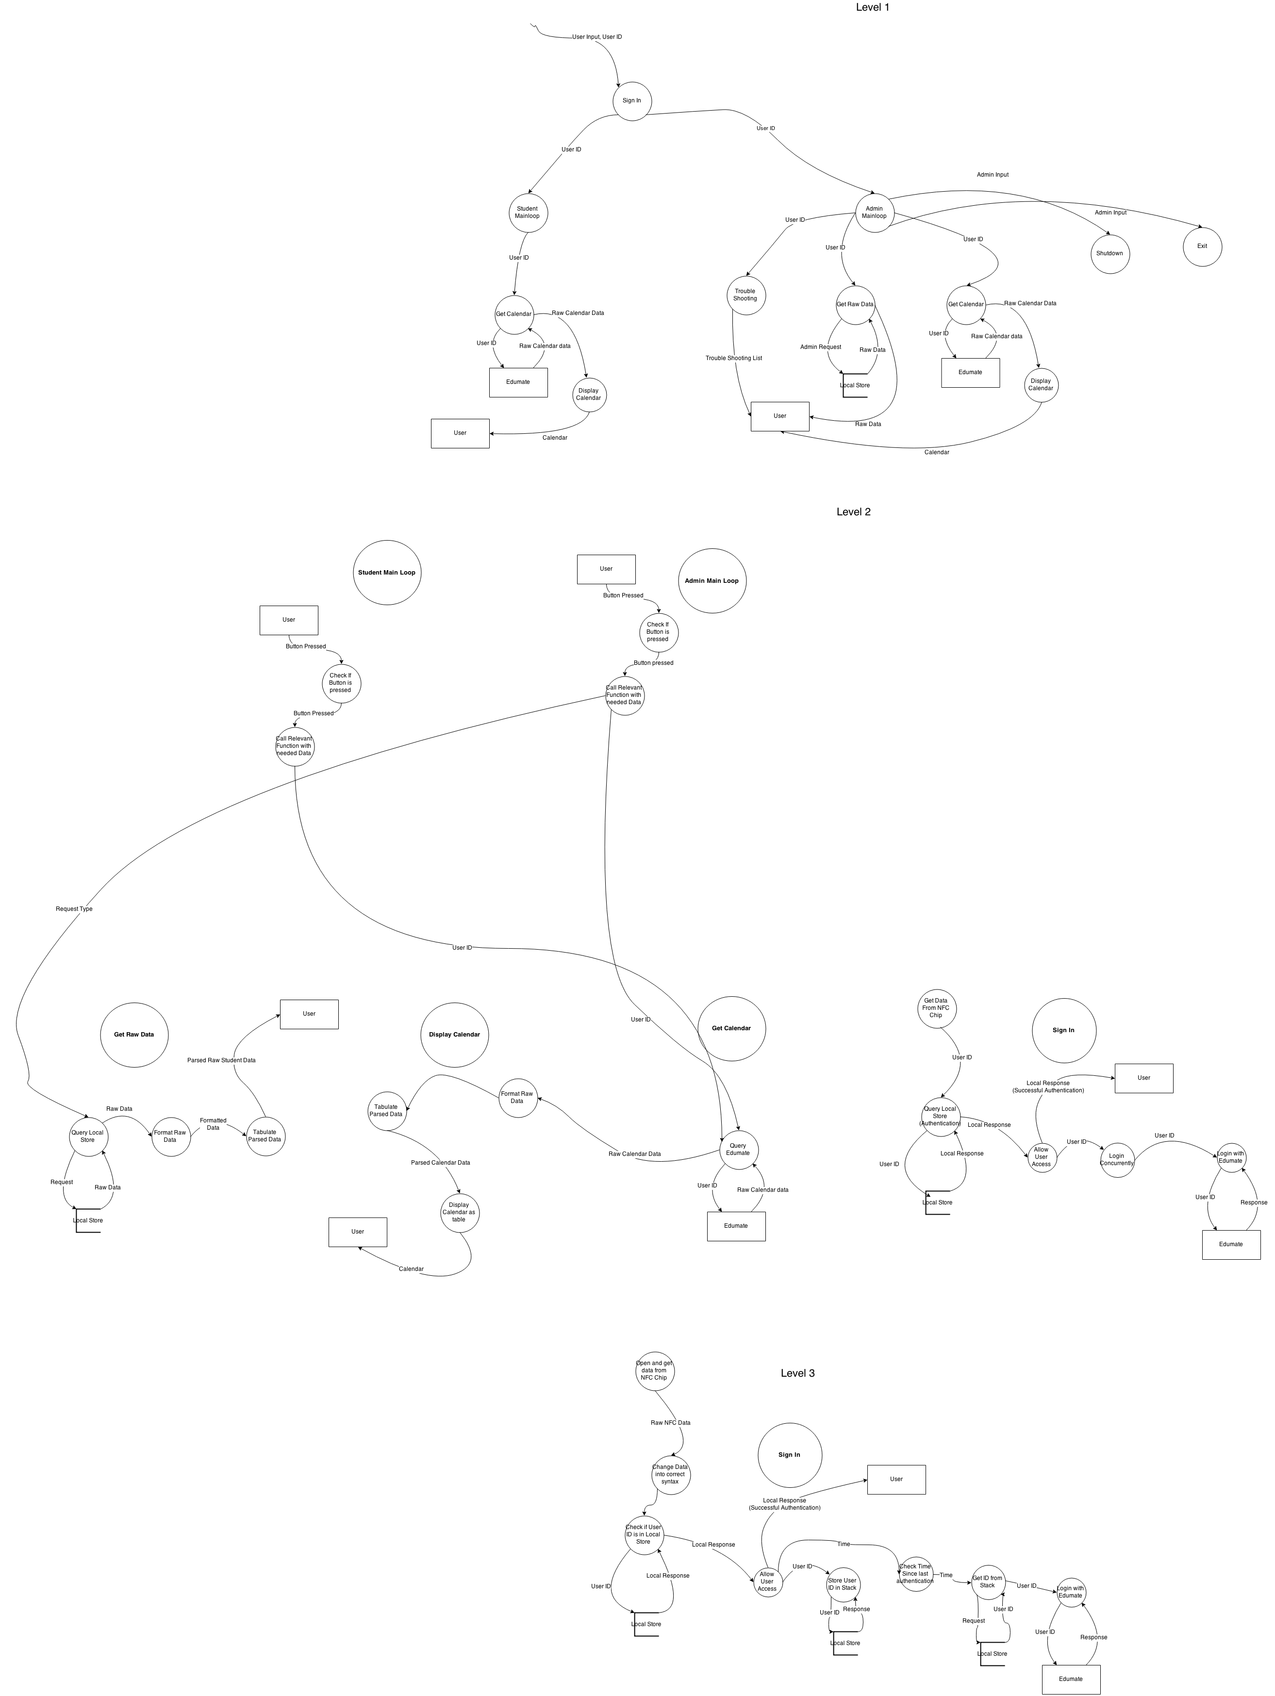

Structure Chart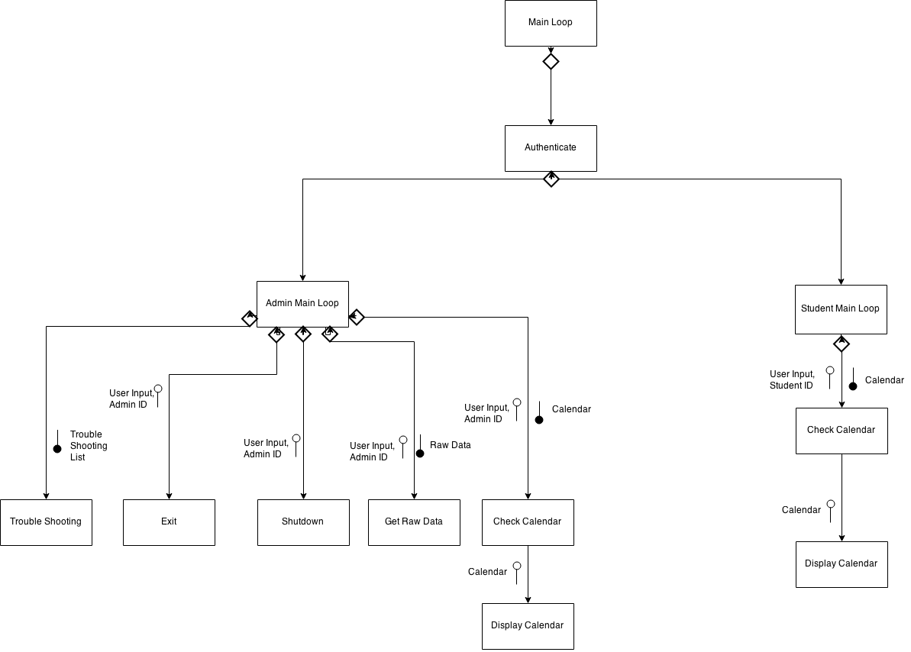

# System Flowchart

# 

# Data Dictionary

|  |  |  |  |  |  |  |
| --- | --- | --- | --- | --- | --- | --- |
| **Field Name** | **Data Format** | **Data Type** | **Field Size** | **Description** | **Example** | **Validation** |
| Card Data | UUID: XX XX XX XX | String | Approx 30 Bits | Data returned from the NFC Scan | UUID: 63 bc 69 d0 |  |
| Student ID | XXXXXXX | Integer | 17 – 20 Bits | Identification Number | 123456 | Must be 6 digits long |
| Admin ID | XXXXXXX | Integer | 17-20 Bits | Identification Number | 123456 | Must be 6 digits long |
| Authentication Stack | [ID1, ID2] | Array of Integers | Approx (At most) 1000 Bytes | The list of User ID’s to be authenticated with edumate |  |  |
| Raw Data (From Edumate) | [ID1, ID2 ] | Array of Integers | Approx (At Most) 1000 Bytes | Array of the ID’s that have been authenticated | [012345,678912] |  |
| Calendar (From Edumate) | [[Teacher, Subject, Class]] | 2 Dimensional Array | Approx 24 *17-20 bits | Raw Data From | [[Mr Drake, SDD, B42],[Ms Laumberg, Maths, B43]] |  |
| Authentication Response (Edumate) | True/False | Boolean | 1 Byte | Login Pass or Fail Response | True | Must be boolean |
| Authentication Response (Local) | True/False | Boolean | 1 Byte | Login Found or Not Found Response | False | Must be boolean |

# Gantt Chart

Old Gantt Chart

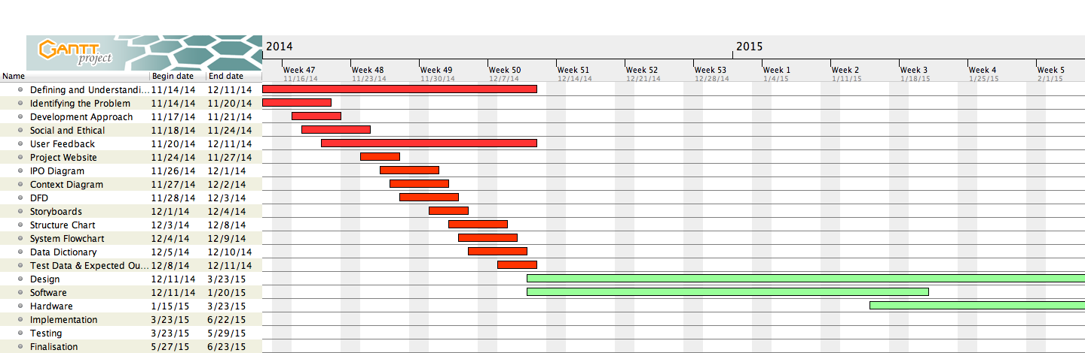

Updated Gantt Chart

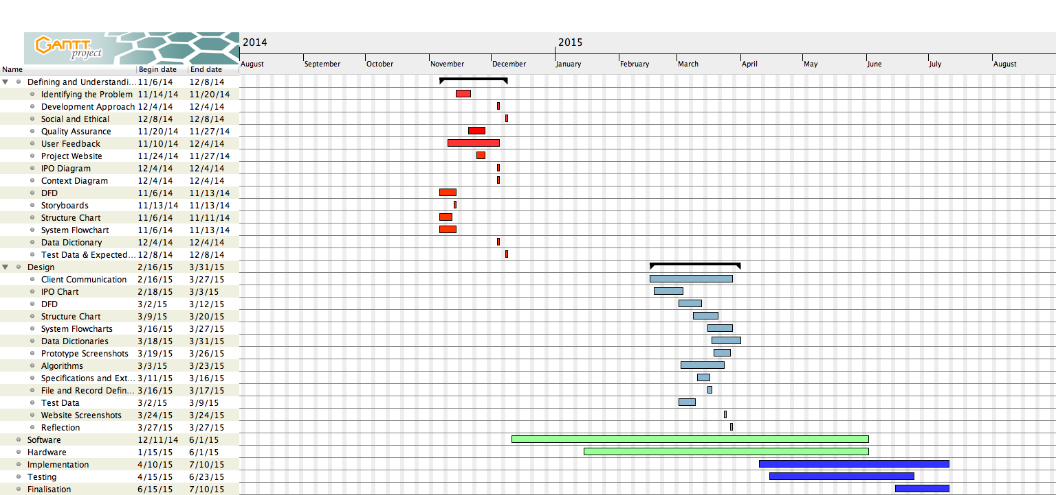

Client Communication

# Surveys

|  |  |  |  |  |  |  |  |  |  |  |
| --- | --- | --- | --- | --- | --- | --- | --- | --- | --- | --- |
| Timestamp | What is your role in Emanuel School? | What Time Do You Get To School Each Day? | Do You Catch The School Bus? | Do You Think There Is A Problem With Our Current Attendance System? | If You Answered Yes To The Last Question, Please Expand On Said Problems. | What Would You Like To See In A New Attendance System? | Do You Use Edumate To Check Your Calendar? | Do You Like The Idea Of An Opal Card Style Attendance System | Would You Use Edumate More If You Could Check Your Calendar Using Your Opal Style Card At A Computer Around The School? | Do You Think We Need A New Attendance System? |
| 12/2/2014 11:28:39 | Student | 8:20:00 AM | No | No | No | No fundamental changes to the system | Yes | No | Yes |  |
| 12/2/2014 11:42:33 | Student | 7:15:00 AM | No | No | N/A | Faster and easier | Yes | Yes | Yes |  |
| 12/2/2014 16:12:44 | Student | 8:10:00 AM | No | No | honestly don't know what the attendance system means | honestly don't know what the attendance system means | Yes | Yes | Yes | No |
| 12/2/2014 17:18:35 | Admin Staff | 10:00:00 PM | Yes | Yes | There aren't any systems in place that use the mass-amounts of Raspberry Pis available to the IT department. | Planning and design documentation | Yes | No | No | Yes |
| 12/2/2014 17:20:36 | Student | 8:15:00 AM | No | Yes | Too much time needed | The cards should look cool | Yes | Yes | Yes | Yes |
| 12/2/2014 18:50:04 | Student | 8:17:00 AM | No | Yes | They don't really keep track of 'all' people coming into the school. | Sure, it would be a great idea! | No | Yes | Yes | Yes |
| 12/2/2014 18:54:22 | Student | 7:35:00 AM | No | No | I did not answer yes | something faster and easier to use. | Yes | Yes | Yes | No |
| 12/2/2014 19:10:24 | Student | 8:18:00 AM | No | No | N/A | I think the system is good as is. | Yes | No | No | No |
| 12/2/2014 19:17:34 | Student | 7:45:00 AM | No | No | It's hard to tell really, I think the computer system stuffs up attendance too frequently though. | Something easy to follow and more reliable that doesn't say someone isn't here when they are | No | Yes | Yes | Yes |
| 12/2/2014 19:27:43 | Student | 8:40:00 AM | Yes | Yes | Too many kids are being too lazy and are not signing in at the office. | Just like at Sydney Boys, each student should have to swipe a card as they walk through the gates which will monitor on the school system what time kids arrive and leave school.  Each student should get assigned a card. | Yes | Yes | Yes | Yes |
| 12/2/2014 20:13:32 | Student | 8:15:00 AM | Yes | No |  |  | Yes | Yes | Yes | No |
| 12/2/2014 20:40:54 | Student | 8:00:00 AM | No | Yes | Occasionally, even though on an excursion students are marked as absent | An online way for students to give their reasons for not attending school or being late | Yes | Yes | Yes | Yes |
| 12/2/2014 21:52:45 | Student | 8:22:00 AM | No | Yes | When you come late, whether you sign in or not you're usually classified absent in period 1 | When signing in it actually telling my teachers I'm there | Yes | No | No | Yes |
| 12/3/2014 19:23:36 | Student | 8:49:00 AM | No | No | I didn't say no | I think this one is fine | Yes | No | No | No |
| 12/8/2014 19:12:25 | Student | 8:00:00 AM | No | No | No | Convenience and a understandable system | No | Yes | Yes | No |
| 12/9/2014 21:11:17 | Teacher | 8:00:00 AM | No | Yes | It would be ideal if students were able to swipte in and out at the gate as they arrive to School. | I would merely like the existing system improved to reflect the opportunity to swipe in and out at the gate, electronically marking the roll. | Yes | Yes | No | No |
| 12/9/2014 21:14:52 | Teacher | 8:00:00 AM | No | Yes | It is clunky and creates too much work for the teacher | Less work for the teacher | Yes | Yes | Yes | Yes |
| 12/9/2014 21:18:42 | Teacher | 8:00:00 AM | No | Yes | Some late students bypass Reception and do not sign in | Private music lessons indicated on Edumate | Yes | Yes | Yes | No |
| 12/9/2014 21:22:12 | Teacher | 7:45:00 AM | No | Yes | it is only as effective as the teacher who enters the data | a way of students logging attendance as they walk through the gate | Yes | Yes | No | Yes |
| 12/9/2014 21:23:03 | Teacher | 8:15:00 AM | No | No | I said no! | That staff can sign out if they need to pop out of campus during the day, instead of signing out at Reception | Yes | Yes | Yes | No |
| 12/9/2014 21:31:53 | Executive | 7:30:00 AM | No | No | It's not the system, it the human errors that stem from the fact that some people do not follow procedures. | What is meant by 'system'? | No | No | No | No |
| 12/9/2014 21:44:17 | Teacher | 8:00:00 AM | No | No | I didnt answer yes | I dont want one | Yes | Yes | No | No |
| 12/9/2014 21:58:39 | Teacher | 7:30:00 AM | No | Yes | It is automated to alert tutors who then alert parents. Perhaps it should immediately alert parents. But perhaps this is a bad idea - don't know! | It is automated to alert tutors who then alert parents. Perhaps it should immediately alert parents. But perhaps this is a bad idea - don't know! | Yes | Yes | No | Yes |
| 12/9/2014 22:09:34 | Teacher | 7:50:00 AM | No | Yes | difficult to use; often makes mistakes | ease; accuracy; not complicated | Yes | No | No | Yes |
| 12/10/2014 7:02:26 | Teacher | 7:00:00 AM | No | Yes | I run a tutor group, and there is little to no feedback for me for students who are late, absent or truant when I mark them down. | However, we do need a better means to tracking arrival of students in the morning: perhaps each student could have a passcard that they scan as they walk into the school each morning: the system is already in place to allow teacher access - it would not take much to add two additional card readers in the morning, and then the system could automatically update as students entered/left campus. | Yes | Yes | No | No |
| 12/10/2014 7:41:59 | Teacher | 7:30:00 AM | No | No | No problem but I'm sure if i thought about it more there might be some alternate options | My answer is really maybe but no option there to say that. I like the suggestion of the opal card style system you refer to below | Yes | Yes | No | No |
| 12/10/2014 8:33:59 | Teacher | 8:30:00 AM | No | No | No reason to expand | Easier | Yes | Yes | Yes | No |
| 12/10/2014 8:34:49 | Teacher | 6:15:00 AM | No | Yes | Marking rolls in advance prior to offsite classes | ease of monitoring students | Yes | Yes | No | Yes |
| 12/10/2014 9:11:30 | Teacher | 8:00:00 AM | No | No | N/A | N/A | Yes | Yes | No | No |
| 12/10/2014 10:52:31 | Teacher | 8:00:00 AM | No | Yes | In period 0 there are sometimes big events where it is difficult to mark the roll accurately. Some students arrive late and do not sign in. It is also difficult for casual teachers to mark the roll at events as they do not know what the students look like. | I would say that if it adheres to the legislature and it is easier and more convenient for staff and students, it is a good idea. However, I attended a school that tried a swipe-on style of attendance and there were many issues. For example, students lost their cards and some were dishonest and had their friends swipe on for them when they were not actually at school themselves. | Yes | No | No | Yes |
| 12/11/2014 8:39:50 | Teacher | 7:40:00 AM | No | No | NA | NA | Yes | Yes | No | No |
| 12/15/2014 10:41:33 | Teacher | 8:15:00 AM | No | Yes | Not very accurate | Something that reduced human error | Yes | Yes | No | Yes |

A summation of what is conveyed in the above, badly formatted, survey is that many Student and in particular staff would like to see a more accurate, efficient and reliable system for singing in both students and teachers into Edumate. In particular a lot of the issues with the current system seem to stem from the human element of singing students in. For example “*In period 0 there are sometimes big events where it is difficult to mark the roll accurately. Some students arrive late and do not sign in. It is also difficult for casual teachers to mark the roll at events as they do not know what the students look like.”* This was an answer to one of the survey questions by a teacher who’s sentiments perfectly embody what I understand to be the main problems with the system that is in place right now.

# Communication with Executives and Students

**6/03/15**

**Mr Majsay:**

Communications with Mr Majsay, conveying sentiments from both a Head of Studies point of a view and a Head of Music point of view gave me some extremely interesting feedback of what he thought of the current specifications of my project. Mr Majsay said:

* The project so far is a very good idea and a much needed evolvement of the current system
* The functionality sounds extremely useful but there are other things it needs to be able to do
  + The ability to sign into different places for different activities
    - Music Lessons
    - Exams
    - Excursions
  + He expressed a significant importance on singing in for exams because currently the only way that it is actually known if a student was present on exam day is if they wrote the exam or not

**12/06/15**

**Matan Ligman:**

* If the teachers don’t see me I’m marked absent
  + So sometimes I’m at school from period 1-3 but not for 4 because I’m absent and then I need a note for it
* The late to school part is fairly standard
  + I like the use of the automated swipe card – it’s simple
* With this system teachers can’t mark me absent – there are no arguments about teachers not seeing me
* Instead of memorising my calendar the day before I can now check it whenever I like.

**18/06/15**

**Jonathan Moallem**

* I have no incentive to sign into school when I’m late, it’s not interesting
  + For example today I’m not even marked here!
* This proposed system solves my problem in terms of interest because I don’t even have to go out of my way
* But also this new system interests me far more and allows me to look at my calendar

**23/06/15**

**Joshua Doust:**

* Whenever I go to a music lesson I’m marked absent in my class, when I’m actualy in class
* The same thing happens when I’m on an excursion or extra-curricular event
* If I come to school late and I’m in a rush I get marked absent for that period even though I’m in class because it takes to long to go to reception
* The proposed functionality of this new system seems to solve these problems and will enable me to sign into school when I’m late much faster

**24/06/15:**

**Unnamed Executive:**

* As I was in the process of showing off my prototype to a few friends an executive, who I am not at liberty to name had a look at it.
* They said that they were very impressed with the level of care and detail that had gone into creating the prototype this far
* Like Mr Majsay they were interested in seeing the ability to sign in for different activities Including
  + Excursions
  + Exams
  + Music Lessons
  + Extra Curricular activities
* This executive said that even without a touch screen, the small and compact nature of the physical attributes I described make this an extremely viable option for actual implementation in the school at a later date.

Algorithms

# Authenticate

BEGIN Authenticate

OPEN NFC/RFID Card

GET Card_Data FROM NFC/RFID

User_ID = Card_Data[0]

OPEN Local DB For Relative

Auth = Search Local DB for User_ID

If Auth != Null:

Save Stack.append(User_ID) to Local DB

Open Admin.txt For Sequential Access

Read ALL From Admin.txt as Admins

Admin = False

For i in range FROM (0, len(Admins)):

If User_ID == Admins[i]:

Admin = True

Return True, Admin, User_ID

Else:

Return False

Close Local DB

Close Admin.txt

Close NFC/RFID Card

END Authenticate

# Get Raw Student Data

BEGIN Get_Raw_Data

OPEN Local DB FOR Relative Access

GET Stack from Local DB

Return Stack

Close Local DB

END Get_Raw_Data

# Trouble Shooting

BEGIN TroubleShooting

DISPLAY TroubleShoot.png

END TroubleShooting

# Check Calendar

BEGIN CheckCalendar(User_ID)

OPEN Edumate DB #Opened Via HTTP

RawData = Search Edumate DB for User_ID

Return RawDataCal #In the format [[Teacher, Subject, Class]]

Close Edumate DB

END CheckCalendar

# Display Calendar

BEGIN DisplayCalendar(RawDataCal)

Table_Rows= []

For i in range FROM 0 TO length(RawDataCal))

Table.append(RawDataCal[i])

NEXT i

Display Table_Rows

END DisplayCalendar

# Main Loop

BEGIN Mainloop()

While True:

If Login_Button is pressed:

Login = Authenticate()

If Login[1] == True:

AdminMain(Login[2])

Else:

StudentMain(Login[2])

END Mainloop

# Admin Main Loop

Begin AdminMain(User_ID)

While True:

If Check_Calendar is pressed:

CheckCalendar(User_ID)

Elif Get_Raw_Data is pressed:

Get_Raw_Data()

Elif Trouble_Shoot is pressed:

TroubleShooting()

Elif Shutdown is pressed:

Shutdown()

Elif Exit is pressed:

Exit()

END AdminMain

# Student Mainloop

Begin StudentMain(User_ID)

While True:

If Check_Calendar is pressed:

CheckCalendar(User_ID)

END WHILE

END StduentMain

Miscellaneous Documentation

# Specifications & External Modules

External Modules:

* LIBNFC
* Python Libraries (All part of the Standard Libraries)
  + Commands
  + Time
  + Tkinter
* eGalax Touchscreen Drivers (Installed in Rasbian Kernel)

Specifications:

* Raspberry Pi Model A+ (Model A, B and B+ may work but I have not tested them)
* Raspian Wheezy OS (Other OS’s would require other drivers that I have not tested)
* Libnfc V 1.7
* Python V 2.7 or Higher

# File & Record Definitions

|  |  |  |
| --- | --- | --- |
| File or Record | Use | Structure & Example |
| Frames.py | Main project file. Defines, initializes and builds the GUI as well as handling events and accessing databases | N/A (Written in Python) |
| Local Database | Stores the authentication stack. Stores raw data for access later | |  |  |  | | --- | --- | --- | | User ID | User Name | UUID | | 123456 | Cohen.nathan | 63 bc 69 d0 | |
| Admin.txt | Holds the names and User ID’s of all Admins | ADMINS:  cohen.nathan;123456  Jdrake; 0987654 |
| Nfc-poll.cpp | Program accesses the nfc reader and gets the data from the card | N/A (Written in C++) |

# Test Data

Drivers used in this test data:

|  |  |  |  |
| --- | --- | --- | --- |
| **Driver Name** | **Input** | **Output** | **Use** |
| Local_Login.py | N/A | User_ID (6 Digit Int) | Used to emulate an NFC reader and an algorithm which will change the data from the reader into the appropriate syntax to be returned |
| Edumate.py | Takes a 6 digit User_ID as its input | Outputs a two dimensional array in syntax [[Teacher, Subject, Room]] | Used to emulate its names sake – Edumate - and an algorithm that will put data into the appropriate syntax to be returned |
| Local_DB.py | Takes a request type as input | Output is dependent on request type | Emulates the local database used to store a full list of all valid User_ID’s , the stack of User_ID’s to be Authenticated with Edumate and the program to sync the local list of valid ID’s with Edumate’s |
| Admin.txt | N/A | All the data in the file | This will emulate the local stores list of Admins that may access the admin menu and thus funtionality |

|  |  |  |
| --- | --- | --- |
| **Input** | **Output** | |
| **What did the functions return?** | **Visual Change(s)** |
| User 1 presses login and Taps on with valid ID | Authenticate: True, False, User ID | User sees the ‘Logged in Successfully’ message as well as the new page with check calendar button |
| User 1 Presses Check Calendar and No Valid User ID is stoed | Check Calendar:  Returns Error (User ID Not Valid) | No GUI Change is seen as GUI will not change without valid calendar data |
| User 1 Presses Check Calendar | Check Calendar: Returns Calendar Data (Shown 🡪)  Display Calendar:  Returns Frame  (Shown 🡪) | User sees a new page with the returned calendar in table form as well as a ‘Go Back’ Button |
| Admin User 1 presses login and taps on with valid admin ID | Authenticate:  True, True, User_ID | User sees a new page with all the different possible buttons an Admin may want |
| Admin presses Trouble shooting button | N/A | User sees the trouble shooting list with a ‘Go Back’ button for return to the menu |
| Admin Presses Raw Data Button | Local_DB: [“Nathan Cohen”] | User sees a table with the returned data and a ‘Go Back’ button to return to the menu |
| Admin Presses Exit Button | N/A |  |
| Admin presses Shutdown Button | N/A |
| Admin Logs Out | N/A 🡪 |
| User Logs Out | N/A 🡪 |

# Reflection

The Design phase of my Software HSC Major Project has been an extremely fulfilling and rewarding process. Although at times it has stressed me to an extreme extent, there few things I really regret. I do not believe this stage was really that much different from the last in so far as it was all fairly meaningless documentation that helped me very little in implementing my design and writing the code. What it did do was give me a better idea of how to go about explaining the workings of my project to the IT department who I have to work with at one point or another to get an API for Edumate which, even at the best of times, I doubt exists and is functional. At this point I think it is important to thank Mr Case who has helped me more than I could’ve ever asked by ordering the NFC/RFID chip and the touchscreen for my project. Although I have only had success with the NFC Chip so far the success I have had has essentially finished my project, and as my user feedback has indicated there may be no need for the touch screen interface I designed in the first place. In this stage of the project I have encountered little to no problems, like a leaf floating on the wind I have surpassed the expectations of the tree I was once attached to, this being the class of people I am part of. In saying this I did have to push my limits of concentration and efficiency in being able to complete the task in the given time, having only been given the draft before the notification was actually required to be given to us (2 weeks before) and in this time I had many assessment tasks that were far more pressing than software (Maths, 3U Maths and Chemistry). I was able to overcome this lack of time by working as hard as I possibly can, asking Mr Drake for help as often as possible and peer checking my work. I will re-iterate, as it’s an important part of the outline in the assessment notification – there were NO problems I couldn’t overcome in completing the Design phase of my HSC Major Project. I did however have problems in starting the hardware and software development phase, in so far as I can’t get the touch screen to work which detracted from my general ethos of work. I believe, in my humble opinion, that I have succeded with everything in this phase of the project. Any user that has looked at my prototype has loved it and they have all given me some feedback which I have tried to incorporate into my project. The issue of siging in for different things, unfortunately, cannot be solved until IT give me the Edumate API which, I will again reiterate, I don’t believe exists. In terms of my success I am extremely happy with the level to which I have completed the charts and diagrams in which I lost a lot of marks last assessment. I have made a concerted effort to ask Mr Drake about what I should do differently, and checking this feedback with the course specifications document. If I had the time I would probably have talked to Mr Drake more and earlier and maybe gotten Mr Cases opinion on some of the more finicky pieces of my project as Mr Drake is often distracted in class. One thing I definitely am disappointed in is the fact that firstly, we were only given 2 weeks notice to do a task that I now have 9000 words for and secondly, Mr Drake refused to help us with this task before the week the assessment task is due because of the course we were doing, which was fair enough but he could’ve taught us the course work pertaining to our Major Project closer to the time it was due and we could do that Major Project Work. Overall I’m happy with my performance and I hope that Mr Drake agrees.

# Website Screenshots

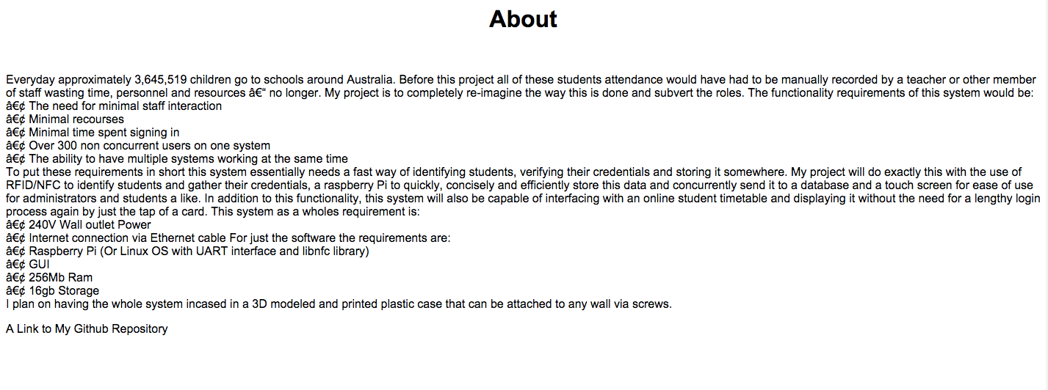

# 

# Prototype Screenshots

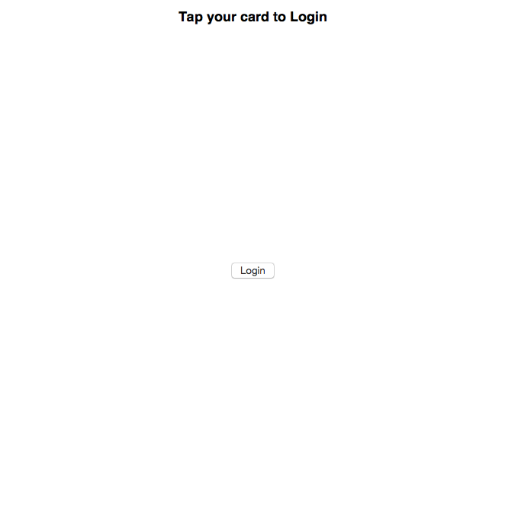

Login Page

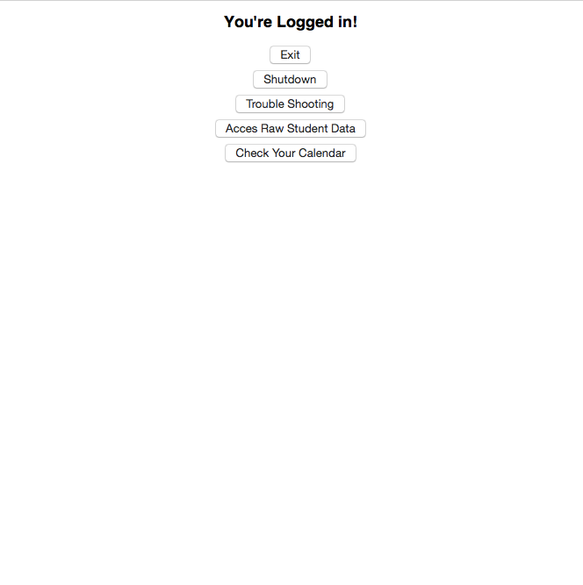

Admin Main Page

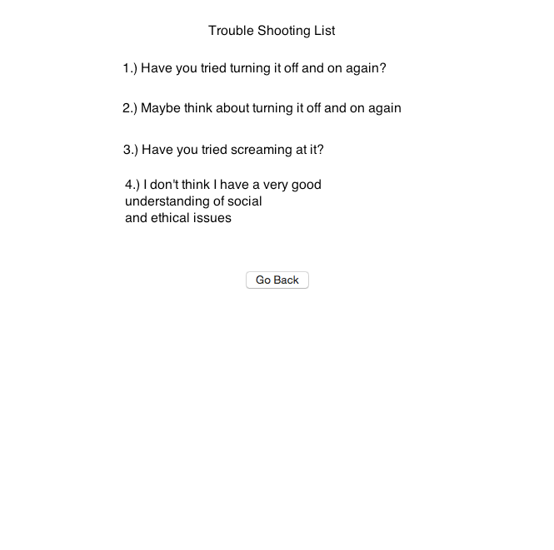

Trouble Shooting Page

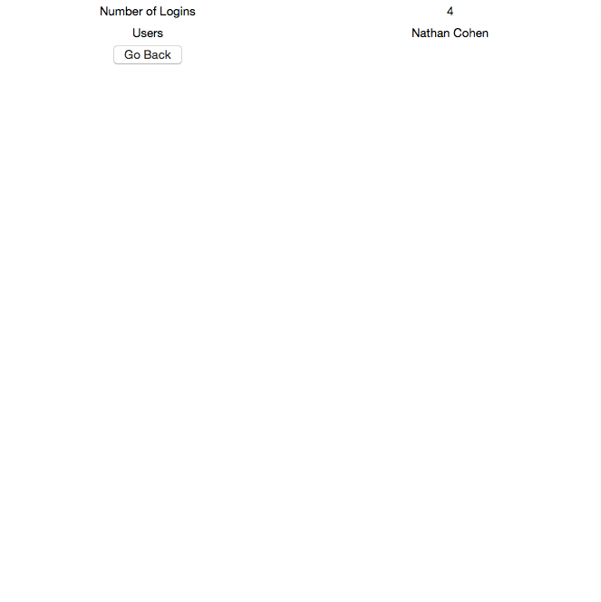

Raw Student Data Page

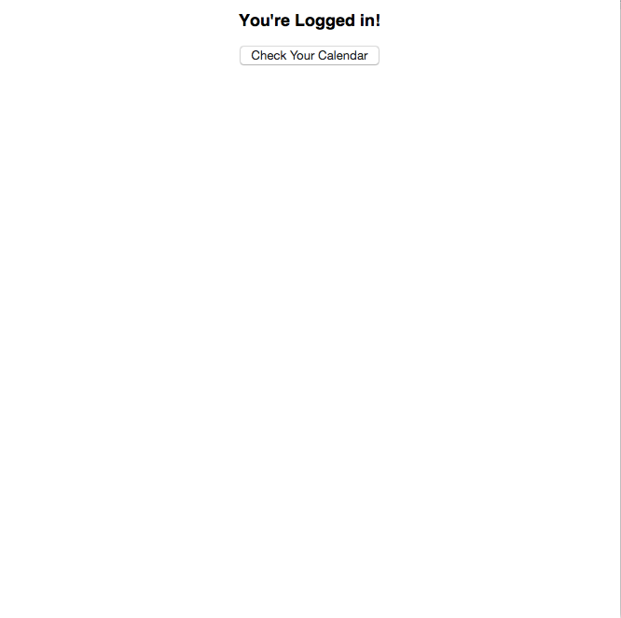

Student Main Page

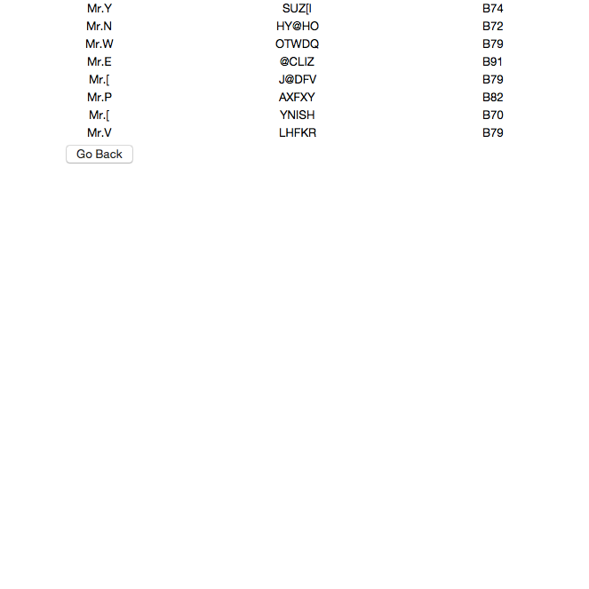

Check Calendar (Admin + Student) Page